.

**DeptofArtificialIntelligenceandMachineLearning**|**RajalakshmiEngineeringCollege**

187

**12-Modules**

**Ex.No. : 12.1 Date:**8/6/24

.

**DeptofArtificialIntelligenceandMachineLearning**|**RajalakshmiEngineeringCollege**

188

**RegisterNo.:231501042 Name: Dinesh Karthik K**

# Powerof2

Given an integer n, print *trueif it is a power of two. Otherwise, print false*. Anintegernisapoweroftwo,ifthereexistsanintegerxsuchthatn==2x. **For example:**

|  |  |
| --- | --- |
| **Input** | **Result** |
| 1 | True |
| 8 | False |

**PROGRAM**

importmath

n=int(input())

print(n>0andmath.log2(n).is_integer())

Output:

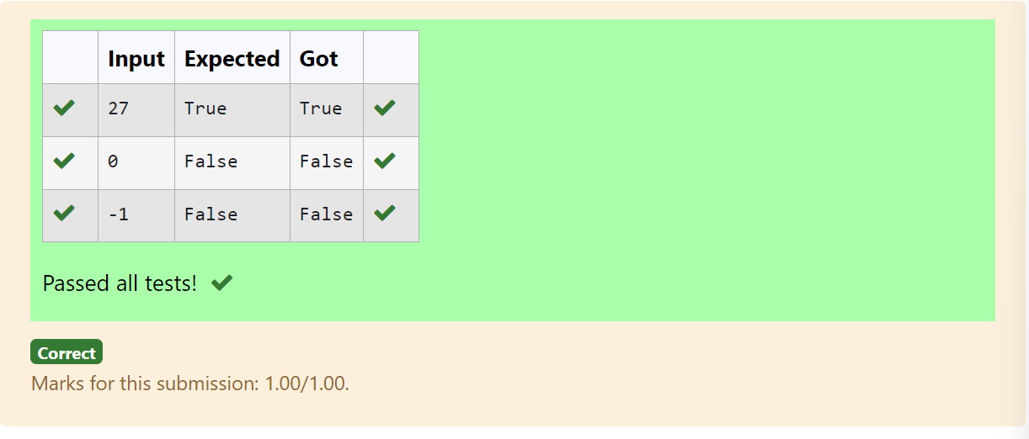

**Ex.No. : 12.2 Date:**8/6/24

**DeptofArtificialIntelligenceandMachineLearning**|**RajalakshmiEngineeringCollege**

189

**RegisterNo.:231501042 Name: Dinesh Karthik K**

# SquareTiles

Background:

Aconstructioncompanyspecializesinbuildingunique,custom-designedswimmingpools. One of their popular offerings is circular swimming pools. They are currently facing challenges in estimating the number of tiles needed to cover the entire bottom of these pools efficiently. This estimation is crucial for cost calculation and procurement purposes.

ProblemStatement:

Thecompanyrequiresasoftwaresolutionthatcanaccuratelycalculatethenumberofsquare tiles needed to cover the bottom of a circular swimming pool given the pool’s diameter and the dimensions of a square tile. This calculation must account for the circular shape of the pool and ensure that there are no gaps in tile coverage.

Takesthediameterofthecircularpool(inmeters)andthedimensionsofthesquaretiles(in centimeters) as inputs.

Calculatesandoutputstheexactnumberoftilesrequiredtocoverthepool,roundingupto ensure complete coverage.

**Forexample:**

|  |  |
| --- | --- |
| **Input** | **Result** |
| 1020 | 1964tiles |
| 1030 | 873tiles |

**PROGRAM**

importmath

diameter,tile_size=map(float,input().split())

radius=diameter/2

area_pool = math.pi * (radius ** 2) tile_size_m = tile_size / 100area_tile = tile_size_m ** 2

tiles_needed=math.ceil(area_pool/area_tile) print(f"{tiles_needed} tiles")

.

**Output:**

.

**DeptofArtificialIntelligenceandMachineLearning**|**RajalakshmiEngineeringCollege**

190

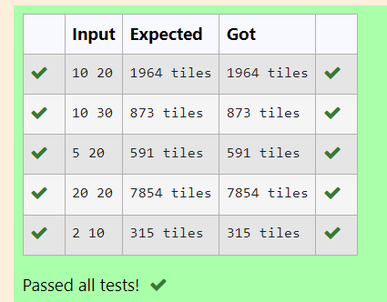

**Ex.No. : 12.3 Date:**8/6/24

**RegisterNo.:231501042 Name: Dinesh Karthik K**

Background:

# ShoeSize

Raghuownsashoeshopwithavaryinginventoryofshoesizes.Theshopcatersto multiplecustomers whohavespecificsizerequirementsandarewillingto payadesignatedamountfortheirdesired shoe size. Raghu needs an efficient system to manage his inventory and calculate the total revenue generated from sales based on customer demands.

**DeptofArtificialIntelligenceandMachineLearning**|**RajalakshmiEngineeringCollege**

191

ProblemStatement:

Develop a Python program that manages shoe inventory and processes sales transactions to determinethetotalrevenuegenerated.Theprogram shouldhandleinputsofshoesizesavailablein the shop, track the number of each size, and match these with customer purchase requests. Each transaction shouldonlyproceedifthedesired shoesizeisinstock,andtheinventoryshouldupdate accordingly after each sale.

InputFormat:

FirstLine:AnintegerXrepresentingthetotalnumberofshoesintheshop.

SecondLine:Aspace-separatedlistofintegersrepresentingtheshoesizesintheshop. Third Line: An integer N representing the number of customer requests.

NextNLines:Eachlinecontainsapairofspace-separatedvalues:

Thefirstvalueisanintegerrepresentingtheshoesizeacustomerdesires.

Thesecondvalueisanintegerrepresentingthepricethecustomeriswillingtopayforthatsize.

OutputFormat:

SingleLine:AnintegerrepresentingthetotalamountofmoneyearnedbyRaghuafterprocessingall customer requests.

Constraints:

1≤X≤1000—Raghu'sshopcanholdbetween1and1000shoes.

Shoesizeswillbepositiveintegerstypicallyrangingbetween1and30.

1≤N≤1000—Therecanbeupto1000customerrequestsinasinglebatch.

Thepriceofferedbycustomerswillbeapositiveinteger,typicallyrangingfrom$5to$100pershoe.

.

**Forexample:**

.

**DeptofArtificialIntelligenceandMachineLearning**|**RajalakshmiEngineeringCollege**

192

|  |  |
| --- | --- |
| **Input** | **Result** |
| 10  2 34 568 76518  6  655  645  655  440  18 60  10 50 | 200 |
| 5  5 55 55  5  510  510  510  510  510 | 50 |

## PROGRAM

no_of_shoes=int(input()) size=input().split() size=[int(x) for x in size] customers=int(input()) total=0

for i in range(customers): new=input().split() new=[int(x)forxinnew] if new[0] in size:

size.remove(new[0]) total+=new[-1]

print(total)

**Output:**

.

**DeptofArtificialIntelligenceandMachineLearning**|**RajalakshmiEngineeringCollege**

193

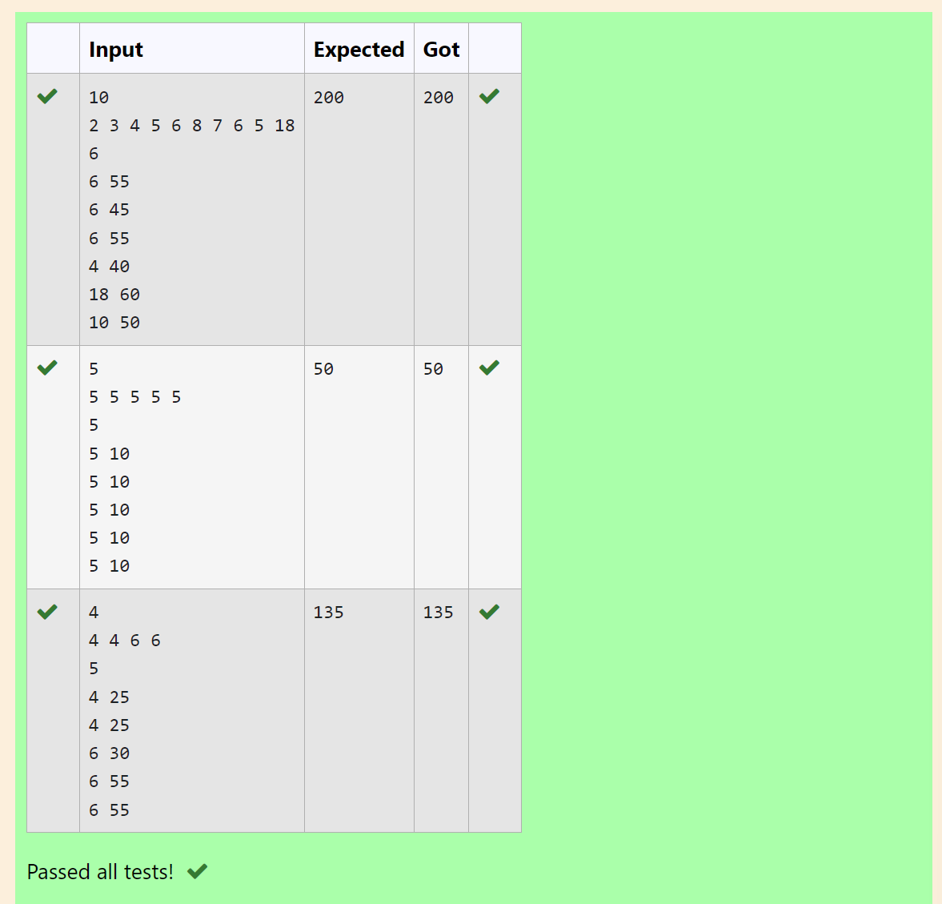

**Ex.No. : 12.4 Date:**8/6/24

**DeptofArtificialIntelligenceandMachineLearning**|**RajalakshmiEngineeringCollege**

194

**RegisterNo.:231501042 Name: Dinesh Karthik K**

# CountUniquePairs

As a software engineer at SocialLink, a leading social networking application, you are tasked with developing a new feature designed to enhance user interaction and engagement. The company aims tointroduceasystemwhereuserscanformconnectionsbasedonsharedinterestsandactivities.One of the feature's components involves analyzing pairs of users based on the activities they've participated in, specifically looking at the numerical difference in the number of activities each user has participated in.

Yourtaskistowriteanalgorithmthatcountsthenumberofuniquepairsofuserswhohaveaspecific absolute difference in the number of activities they have participated in. This algorithm will serve as the backbone for a larger feature that recommends user connections based on shared participation patterns.

ProblemStatement

Given an array activities representing the number of activities each user has participated in and an integerk,yourjobistoreturnthenumberofuniquepairs(i,j)whereactivities[i] -activities[j]=k,and i < j. The absolute difference between the activities should be exactly k.

Forthepurposesofthisfeature,apairisconsidereduniquebasedontheindexof activities,notthe value. That is, if there are two users with the same number of activities, they are considered distinct entities.

InputFormat

Thefirstlinecontainsaninteger,n,thesizeofthearraynums. The second line contains n space-separated integers, nums[i]. The third line contains an integer, k.

OutputFormat

Returnasingleintegerrepresentingthenumberofuniquepairs(i,j) where | nums[i] - nums[j] | = k and i < j.

Constraints:

1≤n≤105

-104≤nums[i]≤104

0≤k≤104

**Forexample:**

.

|  |  |
| --- | --- |
| **Input** | **Result** |
| 5  1 31 54  0 | 1 |
| 4  1 22 1  1 | 4 |

.

**DeptofArtificialIntelligenceandMachineLearning**|**RajalakshmiEngineeringCollege**

195

## PROGRAM

n=int(input()) l=input().split() l=[int(x)forxinl] k=int(input()) sum=0

foriinrange(len(l)):

forjinrange(i+1,len(l)): if abs(l[i]-l[j])==k :

sum+=1 print(sum)

Output:

.

**DeptofArtificialIntelligenceandMachineLearning**|**RajalakshmiEngineeringCollege**

196

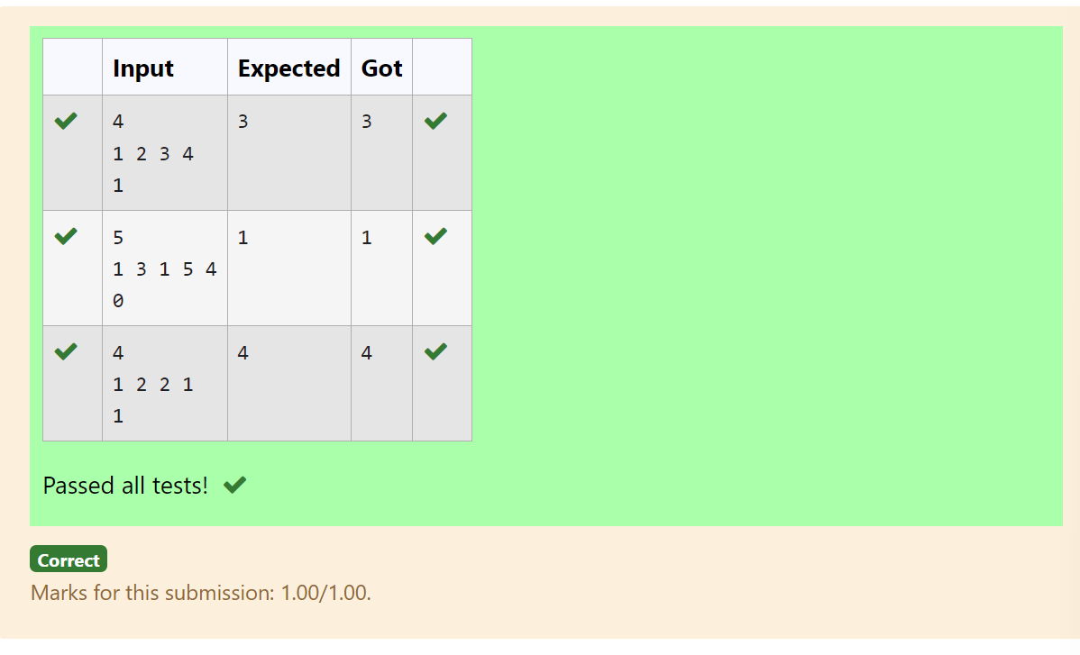

**Ex.No. : 12.5 Date:**8/6/24

**RegisterNo.:231501042 Name Dinesh Karthik K**

Background:

# CalculateAverageMarks

Dr. John Wesley maintains a spreadsheet with student records for academic evaluation. The spreadsheet contains various data fields including student IDs, marks, class names, and student names.Thegoalistodevelopasystemthatcancalculatetheaveragemarksofallstudentslistedin the spreadsheet.

.

**DeptofArtificialIntelligenceandMachineLearning**|**RajalakshmiEngineeringCollege**

197

ProblemStatement:

CreateaPython-basedsolutionthatcanparseinputdatarepresentingalistofstudentswiththeir respectivemarksandother details,andcompute the averagemarks.Theinputmay presentthese details in any order, so the solution must be adaptable to this variability.

InputFormat:

ThefirstlinecontainsanintegerN,thetotalnumberofstudents.

Thesecondlinelistscolumnnamesin anyorder(ID,NAME,MARKS,CLASS). ThenextNlinesprovidestudentdatacorrespondingtothecolumnheaders. Output Format:

Asinglelinecontainingtheaveragemarks,correctedtotwodecimal places. Constraints:

1≤N≤100

ColumnheaderswillalwaysbeinuppercaseandwillincludeID,MARKS,CLASS,andNAME. Marks will be non-negative integers.

**Forexample:**

.

**DeptofArtificialIntelligenceandMachineLearning**|**RajalakshmiEngineeringCollege**

198

|  |  |
| --- | --- |
| **Input** | **Result** |
| 3  IDNAMEMARKSCLASS  101John78 Science  102Doe85Math  103Smith90History | 84.33 |
| 3  MARKSCLASSNAME ID  78ScienceJohn101  85MathDoe102  90HistorySmith103 | 84.33 |

## PROGRAM

importmath

n=int(input())

columns=input().split()

marks_index=columns.index("MARKS")

total_marks = 0 for_inrange(n):

data=input().split()

total_marks+=int(data[marks_index])

average_marks=total_marks/n print(f"{average_marks:.2f}")

**OUTPUT:**

.

**DeptofArtificialIntelligenceandMachineLearning**|**RajalakshmiEngineeringCollege**

199

|  |  |  |  |  |  |
| --- | --- | --- | --- | --- | --- |
|  | **Input** | **Expecte d** | **Got** |  |  |
|  | 3  IDNAMEMARKSCLASS  101John78 Science  102Doe85Math  103Smith90History | 84.33 | 84.3  3 |  |
|  | 3  MARKSCLASSNAMEID  78ScienceJohn 101  85MathDoe102  90HistorySmith  103 | 84.33 | 84.3  3 |  |
| Passedalltests! | | | | | |
| **Correct** | | | | | |

Marksforthissubmission:1.00/1.00